JENKINS INSTALLATION AND CONFIGURATION

To install Jenkins make sure java installed or not, Jenkins runs on JAVA.
java --version
If java not installed, install using below steps.
sudo apt update
sudo apt install defalut-jre
The Java Runtime Environment (JRE) is software that Java programs require to run correctly.
Verify java installation
java --version
In addition to jre we need to install jdk to run some applications and programs of java so, install jdk.
sudo apt install default-jdk
verify java jdk installation
java --version
Now we are going to set the java home environment in ubuntu
First check the java installed location
readlink -f /usr/bin/java
copy the path.
open environment file
nano /etc/environment
At the end the file you need to add
JAVA_HOME="paste" upto amd64" ctrl X ctrl Y
we have successfully added
Here the contents of environment can be viewed
more /etc/environment
we have added the java home, let's verify.
echo $JAVA_HOME
source /etc/environment
now run the echo java
echo $JAVA_HOME
We have successfully set the java home environment.
Now we will see how to run sample java program on ubuntu
vim navyafile1.java
Add following code
class navya1{
public static void main(String args[]){
System.out.println("Welcome to navya in JENKINS");
}
}
save and exit.
javac navya1.java
2 files will be generated as below
navya1.java
navya1.class
Now run program using java navya1
It gives output as “Welcome to navya in JENKINS”

JENKINS INSTALLATION
This is the Ubuntu package repository of Jenkins to automate installation and upgrade. To use this repository, first add the key to your system.
sudo wget -O /usr/share/keyrings/jenkins-keyring.asc \
https://pkg.jenkins.io/debian-stable/jenkins.io-2023.key
Then add a Jenkins apt repository entry:
echo "deb [signed-by=/usr/share/keyrings/jenkins-keyring.asc]" \
https://pkg.jenkins.io/debian-stable binary/ | sudo tee \
/etc/apt/sources.list.d/jenkins.list > /dev/null
Update your local package index, then finally install Jenkins:
sudo apt-get update
sudo apt-get install fontconfig openjdk-17-jre
sudo apt-get install jenkins

post installation,
UNDER JENKINS ENVIRONMENT HOW TO CREATE THE USER
Open any browser then run localhost:8080
8080 is the default port for Jenkins
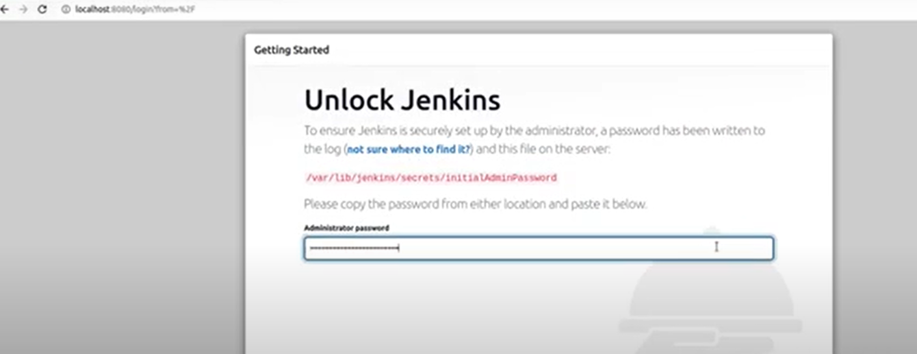
Check the administrator password is stored in file under below file
vim /var/lib/jenkins/secrets/InitialAdminPassword (or)
sudo more /var/lib/jenkins/secrets/InitialAdminPassword
copy the password under above path.
cd /var/lib/jenkins/secrets
paste here.
select install suggested plugins.
It will take some time to install all plugins.

